CS 557 - Winter Quarter 2024 - Project #3 Report

# TITLE: Displacement Mapping, Bump Mapping, and Lighting

*Submitted by: Manogna Challoju*

*Email:* [*challojm@oregonstate.edu*](mailto:challojm@oregonstate.edu)

The goal of this project is to implement displacement mapping, bump mapping, and per-fragment lighting effects to transform a simple shape into a more visually appealing and dynamic surface. By utilizing GLSL shaders, we aim to simulate complex surface deformations, simulate realistic lighting interactions, and enhance the overall visual quality of the rendered scene.

Implementation:

The GLSL code provided enables the implementation of displacement mapping, bump mapping, and per-fragment lighting effects. Key parameters include uA, uB, uC, and uD for controlling the displacement pattern, phase shift and decay rate while also regulating uNoiseAmp and uNoiseFreq for perturbing surface normals, and uKa, uKd, and uKs for specifying material properties. The implementation steps are as follows:

1. Displacement Mapping: Implemented a mathematical function to deform the surface based on radial patterns using the equation Z = A * cos(2πBr+C) * e^(-Dr). Calculated displacement values per-vertex in the vertex shader and updated vertex positions accordingly.
2. Bump Mapping: Utilized noise textures to perturb surface normals based on sampled noise values. Sampled noise values from a 3D texture using model coordinates (vMC) or texture coordinates (vST) depending on the value of uUseXYZforNoise. Rotated surface normals around the X and Y axes based on noise values to simulate surface roughness.
3. Per-Fragment Lighting: Implemented per-fragment lighting to accurately compute ambient, diffuse, and specular lighting effects.Calculated normal vectors by taking the cross product of tangent vectors derived from the displacement function.

The implemented dynamic surface deformation and bump mapping techniques provide visually interesting effects, enhancing the realism and complexity of the rendered scene. By varying parameters such as amplitude (uA), period (uB), decay rate (uD), noise amplitude (uNoiseAmp), and noise frequency (uNoiseFreq), users can experiment with different configurations to achieve diverse visual outcomes. The side-by-side images and video demonstrate the effectiveness of the implemented techniques in creating dynamic and visually appealing surfaces.

**Screenshots and Video:**

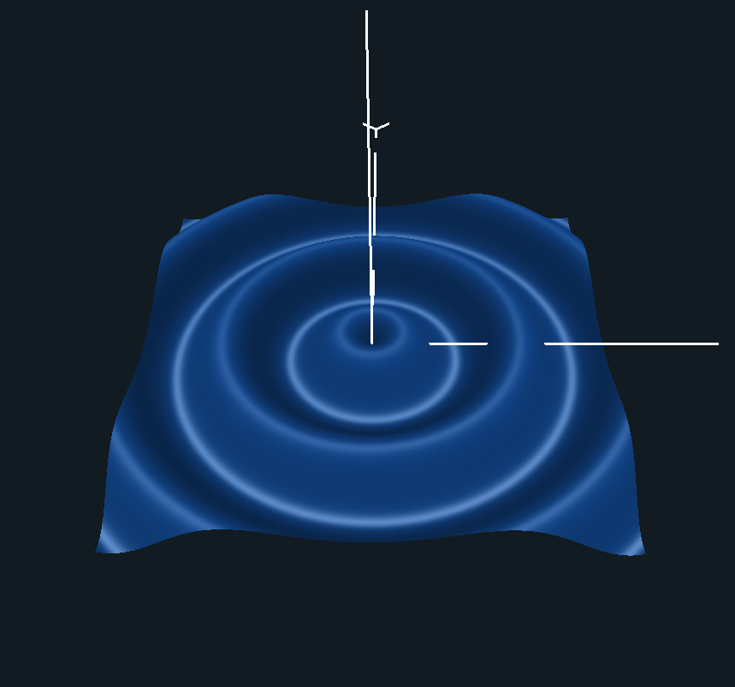

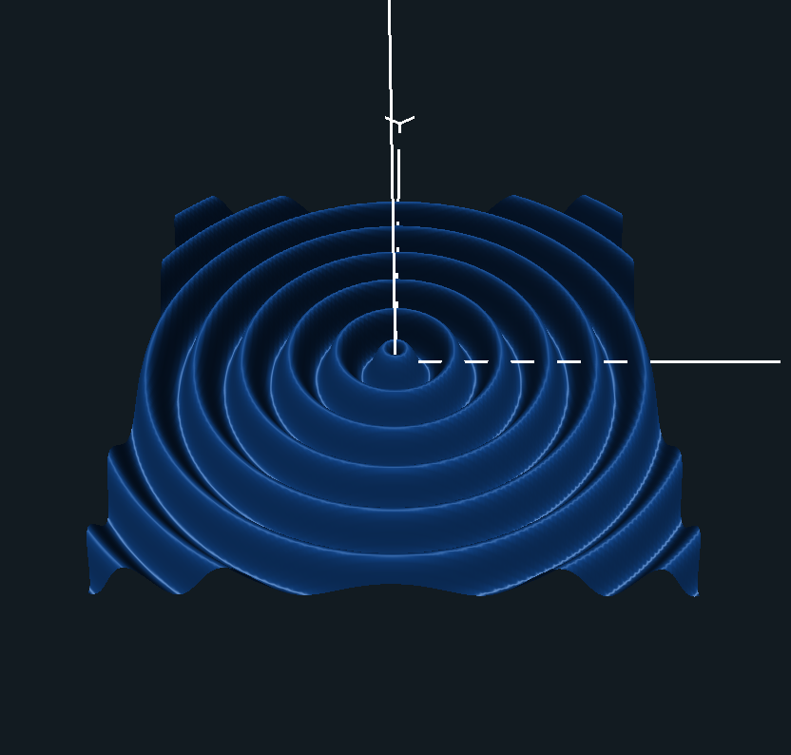

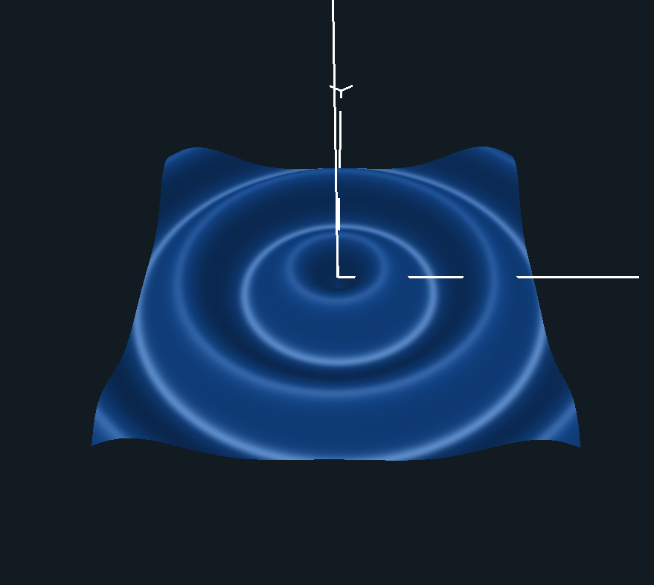

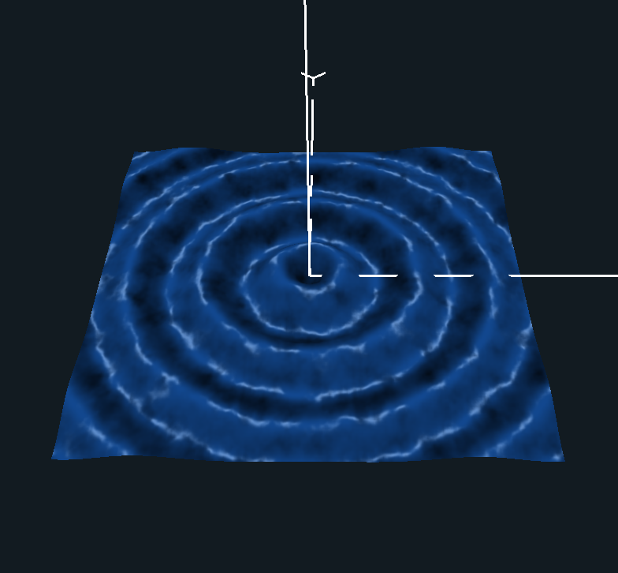

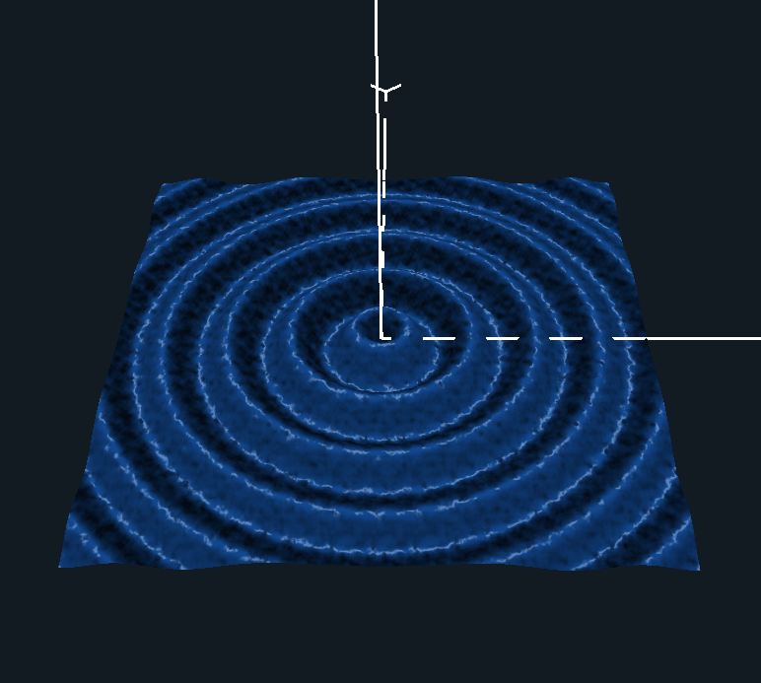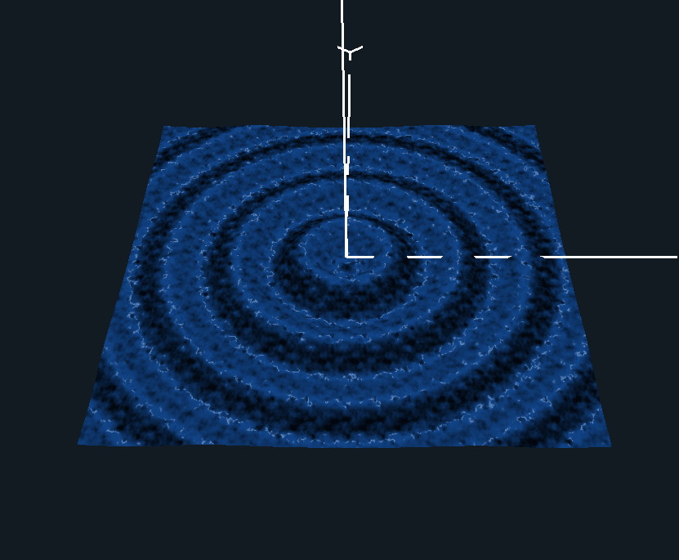

**Kaltura Link** – [Project #3 Displacement Mapping, Bump Mapping and Lighting - OSU MediaSpace (oregonstate.edu)](https://media.oregonstate.edu/media/1_1k2ygzg6)